NAME____________________ Period_______ Due Date___________

Word Cloud Project

Day #2 Computer Lab
- Open your word list from Microsoft Word and minimize it to the bottom of the page.
- Go to the website www.abcya.com
- Click the brown search box and type in Word Clouds and click go.
- Scroll down
- Click on the Word Clouds Box, click the play arrow and click START.
- Go back to your saved word list highlight your whole list, right click and COPY.
- Go back to your word cloud page and right click and PASTE your words into the box.
- Your entire word list should appear in the white word cloud box.
- Click CREATE to get your Word Cloud started.

Use the tool bar to customize and change your Word Cloud.

Once you’re happy with your Word Cloud you need to save it.
Click PRINT SC (Print Screen) this is button right next to F12.
Go back to Microsoft Word and open up a new page

Right click and paste your image into your new WORD Document.

Find the tab PAGE LAYOUT then ORIENTATION change it to LANDSCAPE.

Click on your picture and you will need to crop out everything but the word cloud…..
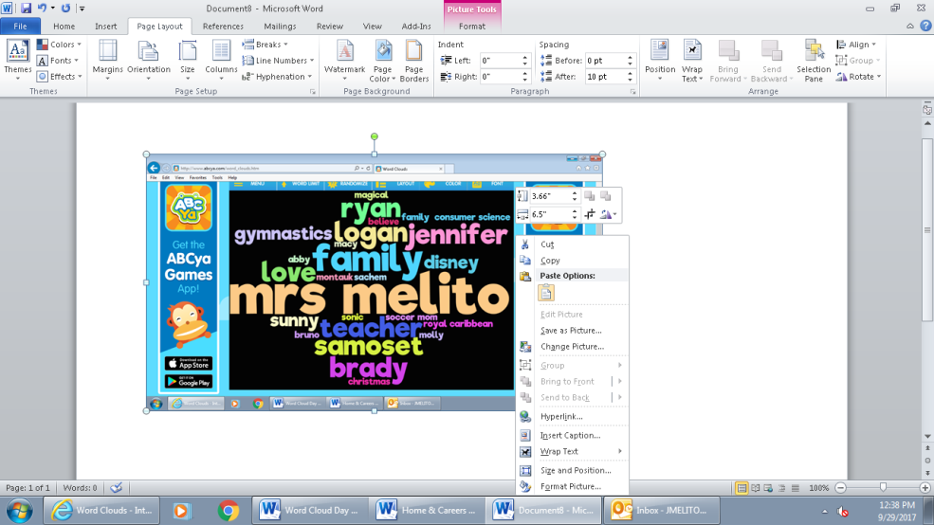
Crop out everything but your word cloud. Make it bigger and then SAVE and PRINT
This is the cropping tool you will use to crop

This is the cropping tool icon

*When printing your final copy please leave a white border around your word cloud so it looks like its framed.
*Place your name and period number on the back!

