Personality Tee-Shirt Project
Goal: Decorate the blank tee-shirt to show some important and unique parts of your personality. Let this tee-shirt advertise what kind of person you are.

Description: Use magazine cut outs, hand drawn pictures, photographs, computer printed pictures and words. You may use other materials as well to create a collage all about you.

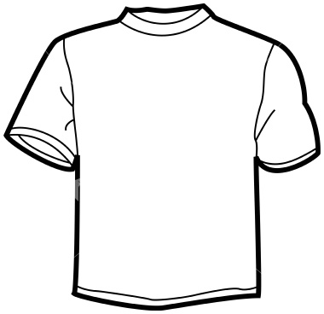
Requirements:
- Minimum of 5 Pictures on the FRONT (30 pts.)
- Minimum of 3 descriptive words on the FRONT (30 pts.)
- You must add color on the FRONT (10 pts.)
- Your shirt must be cut out nice and neat (5 pts.)
- Your full name and period number on the BACK (5 pts.)
- Creativity, Effort and Neatness (20 pts.)
_________________
Total 100% DUE DATE__________

*This will be your first project grade for the 1st quarter*

Personality Tee-Shirt Project
Goal: Decorate the blank tee-shirt to show some important and unique parts of your personality. Let this tee-shirt advertise what kind of person you are.

Description: Use magazine cut outs, hand drawn pictures, photographs, computer printed pictures and words. You may use other materials as well to create a collage all about you.

Requirements:
- Minimum of 5 Pictures on the FRONT (30 pts.)
- Minimum of 3 descriptive words on the FRONT (30 pts.)
- You must add color on the FRONT (10 pts.)
- Your shirt must be cut out nice and neat (5 pts.)
- Your full name and period number on the BACK (5 pts.)
- Creativity, Effort and Neatness (20 pts.)
_________________
Total 100% DUE DATE__________

*This will be your first project grade for the 1st quarter*

