Pasta with Garlic and oil with Broccoli

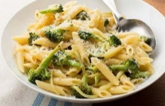
Ingredients
1 Tbsp of minced garlic
1/8 cup olive oil
2 cups pasta
1 cup chopped broccoli
Parmesan Cheese (opt)
Salt & Pepper

Pasta
- Fill large pot ½ way full
- Turn burner to high
- Wait for there to be a rapid boil
- Add pasta
- Return water to a rapid boil
- Stirring frequently
- Check box for pasta cooking time (usually 10-12 mins.)
- Using colander to drain pasta

Broccoli
- In a bowl heat broccoli in microwave for 1.5 minutes.
- When broccoli is soft, remove from microwave and place on a cutting board to chop into bite size pieces
- Add broccoli to saucepan and stir

Garlic and Oil Sauce
- Place saucepan on medium heat
- Add garlic into saucepan
- Stir frequently
- Cook for 3-5 minutes until garlic is golden

Combine pasta, broccoli and garlic and oil!

Enjoy

